**Unit 3. Expert System**

**Lesson 5**

**Whole-Class Activity**

**Task 1.** **Pre-Assessment**

You are going to read questions about expert systems. Use your background knowledge to answer them. You may turn to Activity Pack if you need any scaffolds. You have 5 minutes to complete this task.

Rational Concern

1. What kind of complicated tasks can a computer perform?
2. Is it rational to trust a computer in the sphere of health care?
3. In what areas is computer analysis better than human expertise?

**Analytical Concern**

1. What are the advantages of computer expert systems?
2. What are the disadvantages of computer analysis?
3. In what spheres is it possible to use computer analysis only?

Practical Concern

1. What does the term “expert system” mean?
2. In what way are expert systems connected with artificial intelligence (AI)?
3. Where can AI devices be applied?

Creative Concern

1. How did sci-fi writers see the possibilities of AI technologies?
2. What home appliance would benefit from the use of AI most?
3. How will AI technologies look like in 20 years?

**Task 2. Reading**

Read the text about expert systems and answer the questions. You have 20 minutes for this activity.

1. What is an expert system? a class of computer programs that aim to simulate human reasoning
2. What structure does an expert system have? An expert system has a unique structure, different from traditional computer programming. It is divided into two parts: one fixed – the inference engine and one variable – the knowledge base.

3.What is knowledge base expressed with?

The **knowledge base** is expressed with natural language rules IF ... THEN ... For example:

“IF it is living THEN it is mortal”

“IF his age = known THEN his year of birth = current year – his age in years”

4.What is an inference engine?

The **inference engine** is a computer program designed to produce a reasoning on rules

5.What are the ways to run an inference engine?

The engine has two ways to run: batch or conversational

6.In what spheres are expert systems used?

spheres of its use include interactive or conversational applications, voice server, fault diagnosis, decision support in complex systems, process control, interactive user guide, educational and tutorial software, logic simulation of machines or systems etc.

**Simulating Human Thought**

There is a class of computer programs, known as **expert systems** that aim to simulate human reasoning. The methods and techniques used to build these programs are the outcome of efforts in a field of computer science known as Artificial Intelligence (AI).

An expert system has a unique structure, different from traditional computer programming. It is divided into two parts: one fixed – the inference engine and one variable – the knowledge base. To run an expert system, the engine reasons about the knowledge base like a human. In the 80s a third part appeared: a dialog interface to communicate with users.

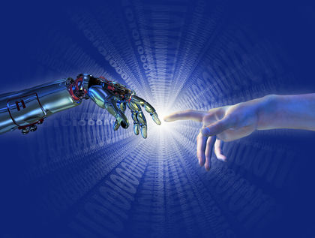In expert system technology, the **knowledge base** is expressed with natural language rules IF ... THEN ... For example:

"IF it is living THEN it is mortal"

"IF his age = known THEN his year of birth = current year - his age in years"

This formulation has the advantage of speaking in everyday language which is very rare in computer science (a classic program is coded). Nevertheless, there exist other formulations of rules, which are not in everyday language, understandable only to computer scientists. Each rule style is adapted to an engine style.

The **inference engine** is a computer program designed to produce a reasoning on rules. In order to produce a reasoning, it should be based on logic. With logic, the engine is able to generate new information from the knowledge contained in the rule base and data to be processed.

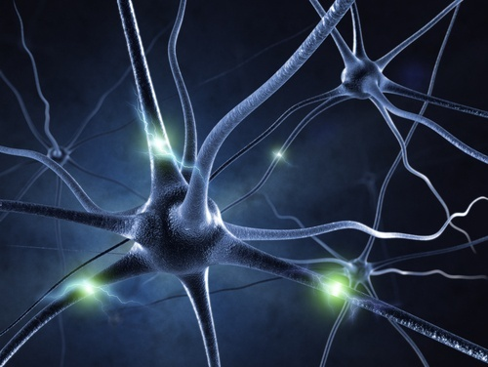The engine has two ways to run: batch or conversational. In batch, the expert system has all the necessary data to process from the beginning. For the user, the program works as a classical program: he provides data and receives results immediately. Reasoning is invisible. The conversational method becomes necessary when the developer knows he cannot ask the user for all the necessary data at the start, because the problem is too complex. The software must "invent" the way to solve the problem, request the missing data from the user, gradually approaching the goal as quickly as possible. The result gives the impression of a dialogue led by an expert.

Expert systems have been built to diagnose disease, find mineral deposits, translate natural languages and solve complex mathematical problems. Other spheres of its use include interactive or conversational applications, voice server, fault diagnosis, decision support in complex systems, process control, interactive user guide, educational and tutorial software, logic simulation of machines or systems etc.

A strong interest in using expert systems is that this kind of software is able to give the user clear explanation of what it is doing (the “Why?”) and what it has deduced (the “How?” ). Nevertheless, expert systems still remain supplements, rather than replacements, for human experts.

(The text is borrowed and modified from http://www.perfectlogic.com/articles/AI/ExpertSystems/ExpertSystems.html and http://en.wikipedia.org/wiki/Expert_system as of 1st June, 2013)

**Task 3. Vocabulary Practice**

Match the terms with their definitions. You have 5 minutes for this task.

|  |  |
| --- | --- |
| 1. Expert system | c. a class of computer programs that aim to simulate human reasoning |
| 1. Knowledge base | a. a set of digitized facts, rules, cases, and models |
| 1. Inference engine | b. computer program designed to produce a reasoning on rules |
| 1. Batch method | g. way of inference engine work, when the expert system has all the necessary data to process from the beginning |
| 1. Conversational method | d. way of inference engine work, when the software request the missing data from the user, gradually approaching the goal |
| 1. Fault diagnosis | e. a process of finding faults arising in systems |
| 1. Tutorial software | f. a computer program which purpose it is to assist users in learning something |

**Task 4. Vocabulary Practice**

There are several suffixes in English which help to form nouns from verbs. Study the following examples of these suffixes and after doing so, make up derivatives from the words in brackets. You have 5 minutes for this task.

-**tion** (generate – generation, calculate – calculation)

-**ment** (judge – judgment, punish – punishment, move – movement)

-**ing** (draw – drawing, code – coding, debug – debugging)

-**ence** (differ – difference, present – presence)

-**er, -or** (manage – manager, develop – developer, create – creator)

Expert systems are computer **applications** (**apply**) that combine computer **equipment** (**equip**), software, and specialized **information** (**inform**) to imitate expert human **reasoning** (**reason**) and advice. As a branch of artificial intelligence, expert systems provide discipline-specific **maintaination** (**maintain**), advice and **explanation** (**explain**) to their **users** (**use**). While artificial intelligence is a broad field covering many aspects of computer-generated **thought** (**think**), expert systems are more narrowly focused. Typically, expert systems function best with specific activities or problems and specific database of facts and rules. Expert systems are used widely in commercial and industrial **settings** (**set**), including medicine, finance, **manufacturing** (**manufacture**), and sales.

(The text is borrowed and modified from http://www.referenceforbusiness.com/encyclopedia/Ent-Fac/Expert-Systems.html as of 1st June, 2013)

**Task 5. Language in Use**

Passive voice is often used in the field of scientific and professional communication. Study the table where the grammatical peculiarities of Passive voice are explained. After doing so, transform the active sentences into passive ones. You have 10 minutes for this task.

|  |  |  |
| --- | --- | --- |
| **Passive Voice**  Passive voice is a specific grammatical form of Verbs. Passive voice is used when the focus is on the action and it is not important or not known who or what is performing the action. Passive voice is formed with the help of the verb *be* in appropriate tense form and *past participle*. When changing active sentence into passive sentence note that:   * the object of the active sentence becomes the subject of the passive sentence * the subject of the active sentence becomes the object of the passive sentence (or is dropped) | | |
| **Tense** | **Voice** | **Example** |
| Present Simple | Active | Developers **create** expert systems to diagnose disease. |
| Passive | Expert systems **are created** (by developers) to diagnose disease. |
| Past Simple | Active | Developers **created** expert systems to diagnose disease. |
| Passive | Expert systems **were created** to diagnose disease. |
| Present Perfect | Active | Developers **have created** expert systems to diagnose disease. |
| Passive | Expert systems **have been created** to diagnose disease. |
| Past Perfect | Active | Developers **had created** expert systems to diagnose disease. |
| Passive | Expert systems **had been created** to diagnose disease. |
| Future Simple | Active | Developers **will create** expert systems to diagnose disease. |
| Passive | Expert systems **will be created** to diagnose disease. |
| Present Continuous | Active | Developers **are now** **creating** expert systems to diagnose disease. |
| Passive | Expert systems **are being created** to diagnose disease. |
| Past Continuous | Active | Developers **were creating** expert systems to diagnose disease. |
| Passive | Expert systems **were being created** to diagnose disease. |
| Modal verbs | Active | Developers **can** **create** expert systems to diagnose disease. |
| Passive | Expert systems **can be created** to diagnose disease. |

* + - 1. 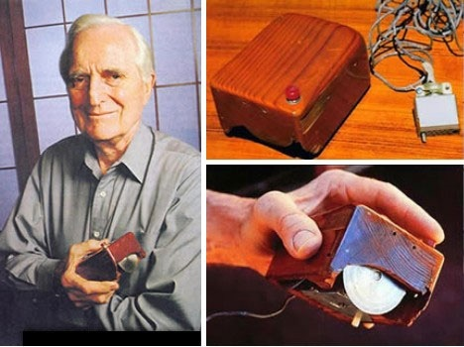Konrad Zuse developed the first electro-mechanical computer in 1939.

The first electro-mechanical computer was developed by Konrad Zuse in 1939.

* + - 1. Hackers release over 6,000 new computer viruses every month.

Over 6,000 new computer viruses are released by hackers every month.

* + - 1. Dough Engelbart constructed the first computer mouse in 1964.

The first computer mouse was constructed by Dough Engelbart in 1964.

* + - 1. People register over 1 million domain names every month.

Over 1 million domain names are registered every month.

* + - 1. People created the first hard drive which could hold 5 MB of data in 1979.

The first hard drive were created in 1979 and it could hold 5 MB of data.

* + - 1. An average video card uses 200 million transistors.

200 million transistors are used by average video card.

* + - 1. Artificial intelligence system can compose music in the style of the composers of the past.

Music can’s composed by artificial intelligence system 1. in the style of the composers of the past.

* + - 1. People released first web browser Mosaic in 1993.

First web browser Mosaic was released in 1993.

* + - 1. People consider Alan Turing to be the father of AI.

Alan Turing are considered as a father of AI.

* + - 1. People will use more than 2 billion computers in 2015.

More than 2 billion computers will be used in 2015.

**Differentiated Activity**

**Task 6.** **Group activity**

In groups, study the content of the text from Task 2 once more and accomplish one of the following tasks. Report your findings to the class. You have 10 minutes for this task.

**Part 1.** Make up synonyms or give an explanation to the following words from the text. Explain them to your groupmates, so that they can guess what word you are talking about.

***Simulate, outcome, field, to reason, rare, conversational, provide, complex, fault, to deduce, supplement, replacement.***

**Part 2.** Explain the following scheme. Choose the appropriate title for it.

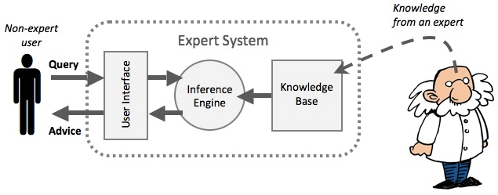

**Part 3.** Make a list of the fields where an expert system can be used and explain how. From the list you have made, choose the sphere where an expert system is most needed and the sphere, where it is not demanded.

**Task 7. http://2.bp.blogspot.com/-vbATVzHj-yo/TvgkOY7ctHI/AAAAAAAABUQ/52IDYUfi6-g/s1600/Audio_Icon.jpg Listening**

You are going to watch a video about an expert system. Choose whatever part you feel confident to complete or do them all. You have 10 minutes for the task. Use the following link to watch the video: http://vimeo.com/43587551.

**Part 1.** Fill in the gaps with the missing information.

COGITO is 1) ………… semantic intelligence platform. It is a technology that takes any kind of text 2) ………. in any kind of format and 3) …………. a deep linguistic analysis by going through all the different steps which lead up to the semantic 4) ………. . The system is then able to understand the meaning of words based on their 5) ……….. . The outcome of the analysis is the 6) …………… , basically, a structured representation of the content, which is then used to run different kinds of 7) ………….. from semantic searchers, to automatic categorization, to competitive intelligence 8) ………… , to natural language interfaces – all which enable a very 9) …………… , fast and precise automatic management of 10) …………. information.

**Part 2.** Complete the sentences and make up definitions of the terms.

1. COGITO is …
2. Semantic analysis enables system to …
3. Conceptual map is basically …
4. The first feature of COGITO is …
5. The second important feature is …

**Part 3.** Explain the two important features of the COGITO system using the sentences given in the text as examples.

**Task 8.** **Pair work**

Write down 5 sentences with Active verbs on a separate piece of paper. After doing so, switch papers with your partner and rewrite the received sentences using Passive Voice. You have 10 minutes for this task.

**Task 9.** **Team work**

You are going to be divided into 2-3 teams. Each team chooses the captain and the name of a team.

In every team, you have to make a list of advantages and disadvantages of the use of artificial intelligence devices. Try to make your lists as long as possible. You have 5 minutes for this task. After that teams read the points from the lists they have made one by one and discuss them if necessary. The team, which has the longest list of advantages or disadvantages wins.

You have time until the end of the class for this activity.

*Advantages* ……………………………………………………………………………………………………………………… *Disadvantages* ………………………………………………………………………………………………………………………

**Home Assignment**

Do Tasks 1-3 from Workbook section.

**WORKBOOK**

**Task 1. Tiered Task**

**Part 1.** Insert the following words in the gaps. Translate the sentences into your native language.

|  |  |  |  |
| --- | --- | --- | --- |
| expressed | based | translate | provides |
| reasons | adapted | simulate |  |

1. Expert systems aim to **1) simulate** human reasoning
2. To run an expert system, the engine **2)reasons**.about the knowledge base like a human.
3. The knowledge base is **3)adapted**.with natural language rules
4. Each rule style is **4)translate** to an engine style
5. In order to produce a reasoning, an inference engine should be **5)based**.on logic.
6. Expert systems have been built to find mineral deposits and **6)expressed** natural languages.
7. The user **7)provides** data and receives results immediately.

**Part 2.** Fill in the gaps.

**Expert system** is a computer program that uses artificial (1) **intelligence** to solve problems within a specialized domain that ordinarily requires human expertise. The first expert system was (2) **developed** in 1965 by Edward Feigenbaum and Joshua Lederberg of Stanford University in California, U.S. Dendral, as their expert system was later known, was designed to (3) **analyze**. chemical compounds. Expert systems now have commercial (4) **applications** in fields as diverse as medical diagnosis, petroleum engineering, and financial investing.

In order to accomplish feats of apparent intelligence, an expert system relies on two (5) **components**: a knowledge base and an inference (6) **engine** A knowledge base is an organized collection of (7) **facts** about the system’s domain. An inference engine (8) **interprets** the facts in the knowledge base in order to provide an answer. Typical tasks for expert systems involve (9) . **classification**, diagnosis, monitoring, design, scheduling, and planning for specialized endeavours.

(The text is borrowed and modified from http://www.britannica.com/EBchecked/topic/198506/expert-system as of 1st June, 2013)

**Part 3.** Write a short description (5-6 sentences) of the way an expert system works. You may use the scheme from Task 6 as a scaffold.

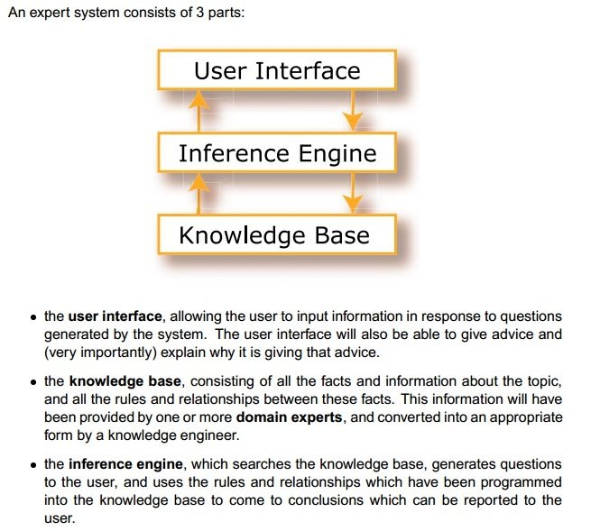

**Task 2. Tiered Task**

Read the text and do at least one part of the task after reading.

In 1950, Alan Turing published his famous article "Computing Machinery and Intelligence", which proposed what is now called the Turing test as a criterion of intelligence. This criterion depends on the ability of a computer program to act as a human in a real-time written conversation with a human judge, sufficiently well that the judge is unable to distinguish reliably between the program and a real human. The  notoriety of Turing's proposed test stimulated great interest in Joseph Weizenbaum's program ELIZA, published in 1966, which seemed to be able to fool users into believing that they were conversing with a real human.

ELIZA's key method of operation (copied by chatbot designers ever since) involves the recognition of cue words or phrases in the input, and giving the output of corresponding pre-programmed responses that can move the conversation forward in a meaningful way (e.g. by responding to any input that contains the word 'MOTHER' with 'TELL ME MORE ABOUT YOUR FAMILY'). Thus an illusion of understanding is generated, even though the processing involved has been merely superficial. The key technique here is the production of responses that are sufficiently vague that they *can be understood* as "intelligent" in a wide range of conversational contexts.

Another example of a chatbot is **Cleverbot** – a web application that uses an artificial intelligence algorithm to converse with humans. It was created in 1997 by AI scientist Rollo Carpenter, who also created Jabberwacky, a similar web application.

Unlike other chatbots, Cleverbot's responses are not programmed. Instead, it "learns" from human input. Humans type into the box and the system finds all keywords or an exact phrase matching the input. After searching through its saved conversations, it responds to the input by finding how a human responded to that input when it was asked, in part or in full, by Cleverbot. Cleverbot participated in a formal, Turing Test at the 2011 Techniche festival. Out of the 334 votes cast, Cleverbot was judged to be 59.3% human, compared to the rating of 63.3% human achieved by human participants. A score of 50.05% or higher is often considered to be a passing grade.

Chatbots are often integrated into the dialog systems of, for example, automated online assistants, giving them the ability of, for example, small talking or engaging in casual conversations. Large companies such as Lloyds Banking Group, Royal Bank of Scotland, Renault and Citroën are now using automated online assistants instead of call centres with humans to provide a first point of contact.

(The text is borrowed and modified from http://en.wikipedia.org/wiki/Cleverbot and http://en.wikipedia.org/wiki/Chatterbot as of 1st June, 2013)

**Part 1.** Answer the following questions.

**1b 2c 3c 4b 5b**

* 1. What is the aim of the Turing test?
     1. To test the ability of a computer to participate in written communication.
     2. **To test the ability of a computer to act as a human.**
     3. To distinguish reliably between a computer and a human.
  2. Joseph Weizenbaum's program ELIZA…
  3. seemed to perform well at the Turing test.
  4. wasn’t able to converse with people.
  5. **was fooling people all the time.**
  6. What is ELIZAs key method of operation?
     1. Creation of an intelligent conversation.
     2. Production of endless responses.
     3. **Recognition of the cue words and giving pre-programmed responses.**
  7. Rollo Carpenter created Jabberwacky, which is…

1. another example of a chatbox.
2. **application simulating the web.**
3. AI science.
   1. How does Cleverbot create its responses?
4. It gives pre-programmed responses.
5. **It searches through previous human responses and gives the matching phrase.**
6. It creates the response using a complicated algorithm.

**Part 2.** Compare the two chatboxes – ELIZA and Cleverbot using the table below:

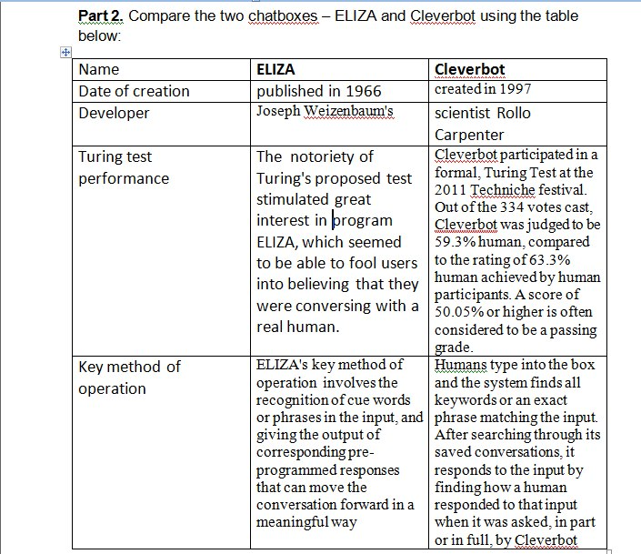

|  |  |  |
| --- | --- | --- |
| Name | **ELIZA** | **Cleverbot** |
| Date of creation |  |  |
| Developer |  |  |
| Turing test performance |  |  |
| Key method of operation |  |  |

**Part 3.** In writing, give your own definition of a chatbot. How have the principles of a chatbot operation changed over time? Where can a chatbot be used? Give your own examples and ideas.

**Task 3. Internet Search**

Visit a Cleverbot site (<http://www.cleverbot.com/>) or any other chatbot and prepare to tell about your conversation. How would you rate the chatbot according to Turing test scale (%)? What are the weak and strong points of a conversation?